PUBLIC HEALTH AWARNESS CAMPAIGN

3rd yr – AI&DS

M.A.M COLLEGE OF ENGINEERING

TEAM MEMBERS,

A.REJOE BLESY

S.SIVA SANKARI

N.YASMEEN NILOFAR

M. MUTHU

A.AYISHA

**Public health campaigns can influence perceptions, attitudes, and even behavior to achieve a desired goal. With digital technologies and human-centered approaches, public health communication leaders have a great opportunity to understand their audiences and tailor campaigns based on their needs.**

**Shifting to the next frontier**

Did you know that health behaviors constitute an estimated 30% of the many factors that determine health outcomes?[1](https://www2.deloitte.com/us/en/insights/industry/public-sector/successful-digital-public-health-campaigns.html#endnote-1) Research suggests that if behavior-related risk factors were eliminated, at least 80% of all heart disease, diabetes, and stroke could be prevented, as could more than 40% of US cancer cases and deaths.[2](https://www2.deloitte.com/us/en/insights/industry/public-sector/successful-digital-public-health-campaigns.html#endnote-2) But, as many public health leaders have experienced, influencing behavior change is exceptionally difficult, especially with limited resources

With the help of targeted and personalized communication efforts, public health leaders can influence health behaviors. Public health leaders across the United States are realizing the power of targeted public health campaigns to get the right message to the right person at the right time. For years, “the golden rule” was to treat others the way you want to be treated. Today, it is being replaced by what many are referring to as “the platinum rule”—treat others the way they want to be treated. This rings true for public health communications as well, where health entities are increasingly looking to craft their communication content based on their audience’s needs instead of dictating the campaign’s messaging uniformly.

One key factor driving this shift in public health campaigns is the rise of digital technologies. Digital technologies are revolutionizing the way public health organizations reach and teach audiences. Unlike the public health campaigns of the past that primarily used television and print modes of communication, modern campaigns are increasingly using digital strategies to maximize their influence on health behaviors.

Consider how one nonprofit organization addressed the challenge of unintended pregnancy among Black and Hispanic teenagers in Syracuse, New York. Rather than building billboards at bus stops or placing pamphlets in the school nurse’s office, The Public Good Projects (PGP)—a public health nonprofit specializing in large-scale social change—recruited local young women to discuss the challenges they encountered while trying to access information about reproductive health. After conducting focus group discussions with more than 30 young women, PGP learned that participants preferred consulting a confidential, trusted “friend” who could address their questions. In collaboration with focus group participants, PGP co-developed a chatbot from scratch, with participants weighing in on the chatbot’s gender, appearance, features, as well as its name: “Layla.”[4](https://www2.deloitte.com/us/en/insights/industry/public-sector/successful-digital-public-health-campaigns.html#endnote-4)

Because “Layla” was created with input from the target audience, she does not sound like a typical public service announcement. She introduces herself like this:

*Hey girl! I’m Layla. Consider me your new best friend with all the deets about those uncomfortable topics like birth control, sex, and STDs. You know, the stuff you’re not exactly running home to talk to mom about ... Have any questions for me? I’m listening!*

Instead of searching the web or having a potentially awkward conversation with an adult, adolescents can connect with a savvy digital confidante who offers responses to sexual health questions. “Layla” uses artificial intelligence (AI), or intelligence generated by machines, and natural language processing, a subset of AI, so teens can type in their questions online and get an immediate reply. Since its launch, “Layla” has received more than 4,000 unique messages related to contraception or sexual health. The campaign content was displayed online over two million times, suggesting wide sharing and viewing of its content, and the campaign generated almost 33,000 unique audience interactions with the campaign, known as engagements.[5](https://www2.deloitte.com/us/en/insights/industry/public-sector/successful-digital-public-health-campaigns.html#endnote-5)

The “Layla’s Got You” campaign shows the power of combining digital technologies with human-centered design, a marketing method that involves incorporating audiences in all steps of the design process, to engage audiences. Our research found that public health campaign strategies such as these, with digital at the center, can increase the efficiency of communications and outreach. (To know more about the research methodology, see sidebar “About the research.”) Moreover, such digital-first campaigns typically cost substantially less to reach a target audience when compared to television, radio, or print advertising, often making them compelling options for public health leaders with resource constraints.[6](https://www2.deloitte.com/us/en/insights/industry/public-sector/successful-digital-public-health-campaigns.html#endnote-6) In 2018, advertisers paid an average US$17.50 CPM (cost per every thousandth person reached) for cable television ads, while national broadcast ads averaged US$32 CPM, and digital ads cost just US$2.80 CPM, representing significant savings.[7](https://www2.deloitte.com/us/en/insights/industry/public-sector/successful-digital-public-health-campaigns.html#endnote-7)

Another advantage of digital campaigns is the ability to interpret audience reactions in real time and assess outcomes on an ongoing basis. Digital campaigns allow for a two-way conversation between the trusted messenger and its audiences, creating ample opportunity for continually improving campaigns based on audience behavior.

### The three-step process to move up the campaign maturity curve

It’s not that organizations don’t realize the importance of using technology in public health campaigns. They do. Several US public health agencies use digital tools and technologies to support their traditional strategies for public health campaigns, using social media or text messages to “get the message out.” However, few public health campaigns have exploited the full potential that emerging technologies have to offer. Many organizations have plenty to do to reach the pinnacle of the campaign maturity curve, (figure 1). The more they advance along this journey, the greater can be their gains in terms of campaign efficiency (measured by the breadth of a campaign’s reach and its scalability) and effectiveness (captures the probability of achieving desired outcomes).

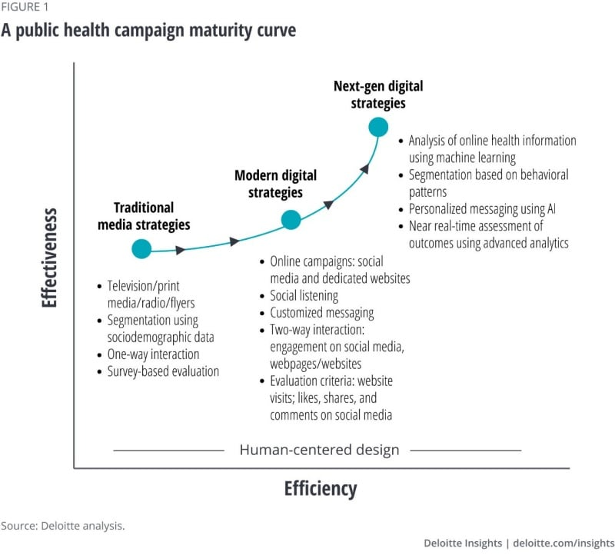audience behavior.

### About the research

The Deloitte Center for Government Insights interviewed public health communications specialists from nonprofit organizations and academic institutions across the United States to understand leading practices and emerging trends shaping the future of digital health campaigns. The insights from the interviews underscored the benefits of digital campaigns, as participants cited the use of data for audience segmentation, leveraging social media influencers for targeted outreach, and using human-centered design to personalize outreach.

### The three-step process to move up the campaign maturity curve

It’s not that organizations don’t realize the importance of using technology in public health campaigns. They do. Several US public health agencies use digital tools and technologies to support their traditional strategies for public health campaigns, using social media or text messages to “get the message out.” However, few public health campaigns have exploited the full potential that emerging technologies have to offer. Many organizations have plenty to do to reach the pinnacle of the campaign maturity curve, (figure 1). The more they advance along this journey, the greater can be their gains in terms of campaign efficiency (measured by the breadth of a campaign’s reach and its scalability) and effectiveness (captures the probability of achieving desired outcomes).

[](https://www2.deloitte.com/us/en/insights/industry/public-sector/successful-digital-public-health-campaigns/_jcr_content/root/responsivegrid_380572564/advanced_image.coreimg.95.800.jpeg/1686308156020/us164491-figure1.jpeg)

Our research suggests that a three-step process (figure 2) can help these organizations unleash the potential of digital technologies and move up the campaign maturity curve.

[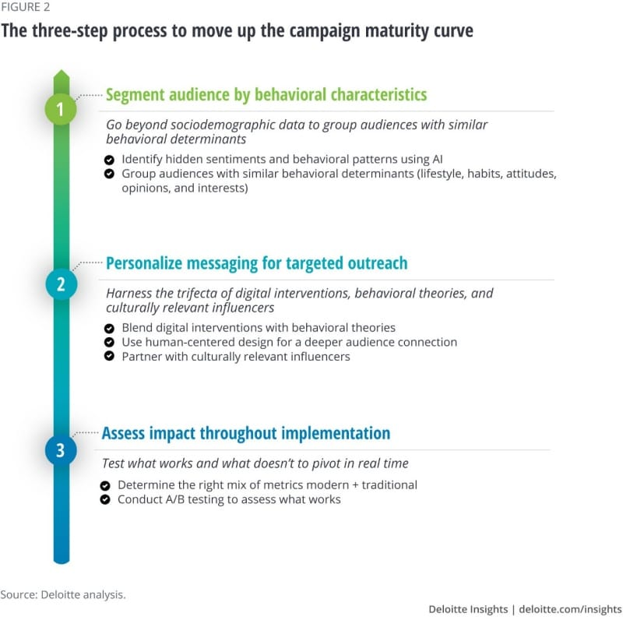](https://www2.deloitte.com/us/en/insights/industry/public-sector/successful-digital-public-health-campaigns/_jcr_content/root/responsivegrid_380572564/advanced_image0.coreimg.95.800.jpeg/1686308156035/us164491-figure2.jpeg)

#### Step No. 1: Segment audience by behavioral characteristics

Public health leaders will be familiar with the phrase, “know thy audience.” It may be no surprise, then, that defining audience groups, or segmenting, can help derive deeper insights. But what is important is how you segment an audience. In the past, campaign strategists often segmented audiences based on demographic characteristics such as age, gender, race, and marital status. Today, there is more to segmenting than that: Modern campaigns are grouping audiences based on behavior.

Behavioral segmenting can help identify subgroups of an intended audience with shared behavioral characteristics, allowing campaigns to conduct targeted messaging. Simply put, rather than grouping audiences by identity, behavioral segmentation creates groupings based on what drives audience actions. For instance, their attitudes, interests, beliefs, values, and lifestyles.

Identifying similarities in behavioral patterns and key behavioral drivers can help a public health agency better target their messaging to different audience segments. According to one public health leader, “The importance of knowing everything about the target audience is critical. Understanding where they are, not just about the issue, in terms of knowledge, attitudes, current behaviors, but where it fits into their life in general and understanding who that audience is, who among that audience is the so-called low-hanging fruit, or sort of reachable and movable.”

##### Identify hidden sentiments and behavioral patterns using AI

Today’s audience consists of a smartphone-using, smartwatch-wearing population. Thanks to these devices, digital data can provide campaign strategists with an opportunity to know their audience better while also understanding patterns in their lifestyles, habits, and beliefs.

However, much of this data is unstructured, including interactions on social media, as well as conversations on public websites and other digital forums. The growing amount of unstructured health-related data can yield important insights into a target audience’s behavioral patterns as well as underlying sentiments. Yet, it would be prohibitively time-consuming to analyze such information manually.

Emerging technologies such as AI can help. Working with campaign strategists, public health leaders can use AI and text mining for social listening, a marketing approach that helps them “listen to” who is discussing an issue, who is socially influential, what they are saying about it, as well as where—digitally and geographically—the conversation is happening. With the help of these technologies, strategists can even interpret the sentiments behind online health discussions and identify the target audience for a campaign.[8](https://www2.deloitte.com/us/en/insights/industry/public-sector/successful-digital-public-health-campaigns.html#endnote-8) It is, however, important to ensure that fears of individual-level data being misused are allayed (see sidebar, “Addressing data privacy concerns”).

Research shows how machine learning (a subset of AI) can help identify the target audience for a public health campaign by interpreting social media conversations.[12](https://www2.deloitte.com/us/en/insights/industry/public-sector/successful-digital-public-health-campaigns.html#endnote-12) For instance, researchers at the University of Pittsburgh attempted to identify people with mixed sentiments toward hookah tobacco smoking (HTS) for a public health campaign aimed at HTS prevention. Given that it’s difficult to manually identify an audience with mixed or ambivalent attitudes, the researchers used sentiment analysis on more than 500,000 HTS-related tweets that these individuals had put out on the Twitter platform from January to June 2016 and applied machine learning to check for users posting both positive and negative tweets (indicating ambivalence) about HTS.

People with mixed sentiments typically displayed one of the following characteristics: 1) had tried HTS only a few times, 2) were against HTS but visited lounges, 3) had lots of peers who used hookah, 4) made conscious efforts to quit HTS, or 5) acknowledged negative effects but still supported HTS. The algorithms made it easier to identify specific audience segments that public health officials could target in potential campaigns focused on HTS cessation.[13](https://www2.deloitte.com/us/en/insights/industry/public-sector/successful-digital-public-health-campaigns.html#endnote-13)

### About the research

The Deloitte Center for Government Insights interviewed public health communications specialists from nonprofit organizations and academic institutions across the United States to understand leading practices and emerging trends shaping the future of digital health campaigns. The insights from the interviews underscored the benefits of digital campaigns, as participants cited the use of data for audience segmentation, leveraging social media influencers for targeted outreach, and using human-centered design to personalize outreach.

### The three-step process to move up the campaign maturity curve

It’s not that organizations don’t realize the importance of using technology in public health campaigns. They do. Several US public health agencies use digital tools and technologies to support their traditional strategies for public health campaigns, using social media or text messages to “get the message out.” However, few public health campaigns have exploited the full potential that emerging technologies have to offer. Many organizations have plenty to do to reach the pinnacle of the campaign maturity curve, (figure 1). The more they advance along this journey, the greater can be their gains in terms of campaign efficiency (measured by the breadth of a campaign’s reach and its scalability) and effectiveness (captures the probability of achieving desired outcomes).

[](https://www2.deloitte.com/us/en/insights/industry/public-sector/successful-digital-public-health-campaigns/_jcr_content/root/responsivegrid_380572564/advanced_image.coreimg.95.800.jpeg/1686308156020/us164491-figure1.jpeg)

Our research suggests that a three-step process (figure 2) can help these organizations unleash the potential of digital technologies and move up the campaign maturity curve.

[](https://www2.deloitte.com/us/en/insights/industry/public-sector/successful-digital-public-health-campaigns/_jcr_content/root/responsivegrid_380572564/advanced_image0.coreimg.95.800.jpeg/1686308156035/us164491-figure2.jpeg)

#### Step No. 1: Segment audience by behavioral characteristics

Public health leaders will be familiar with the phrase, “know thy audience.” It may be no surprise, then, that defining audience groups, or segmenting, can help derive deeper insights. But what is important is how you segment an audience. In the past, campaign strategists often segmented audiences based on demographic characteristics such as age, gender, race, and marital status. Today, there is more to segmenting than that: Modern campaigns are grouping audiences based on behavior.

Behavioral segmenting can help identify subgroups of an intended audience with shared behavioral characteristics, allowing campaigns to conduct targeted messaging. Simply put, rather than grouping audiences by identity, behavioral segmentation creates groupings based on what drives audience actions. For instance, their attitudes, interests, beliefs, values, and lifestyles.

Identifying similarities in behavioral patterns and key behavioral drivers can help a public health agency better target their messaging to different audience segments. According to one public health leader, “The importance of knowing everything about the target audience is critical. Understanding where they are, not just about the issue, in terms of knowledge, attitudes, current behaviors, but where it fits into their life in general and understanding who that audience is, who among that audience is the so-called low-hanging fruit, or sort of reachable and movable.”

In the past, campaigns often segmented audiences based on demographic characteristics such as age, gender, race, and marital status. Today, there is more to segmenting than that: Modern campaigns are grouping audiences based on behavior.

Today’s digital strategies have the power to assess audience actions and identify audiences with similar behavioral traits. Here’s what public health agencies can do to enhance their campaign effectiveness with behavioral segmenting:

##### Identify hidden sentiments and behavioral patterns using AI

Today’s audience consists of a smartphone-using, smartwatch-wearing population. Thanks to these devices, digital data can provide campaign strategists with an opportunity to know their audience better while also understanding patterns in their lifestyles, habits, and beliefs.

However, much of this data is unstructured, including interactions on social media, as well as conversations on public websites and other digital forums. The growing amount of unstructured health-related data can yield important insights into a target audience’s behavioral patterns as well as underlying sentiments. Yet, it would be prohibitively time-consuming to analyze such information manually.

Emerging technologies such as AI can help. Working with campaign strategists, public health leaders can use AI and text mining for social listening, a marketing approach that helps them “listen to” who is discussing an issue, who is socially influential, what they are saying about it, as well as where—digitally and geographically—the conversation is happening. With the help of these technologies, strategists can even interpret the sentiments behind online health discussions and identify the target audience for a campaign.[8](https://www2.deloitte.com/us/en/insights/industry/public-sector/successful-digital-public-health-campaigns.html#endnote-8) It is, however, important to ensure that fears of individual-level data being misused are allayed (see sidebar, “Addressing data privacy concerns”).

### Addressing data privacy concerns

Participants online are often wary of sharing their personal information if they are unsure how it will be used. A 2020 survey by the Pew Research Center stated that approximately 64% of Americans are somewhat or very concerned about government collection of their personal data, and only 4% understand what the government does with their data.[9](https://www2.deloitte.com/us/en/insights/industry/public-sector/successful-digital-public-health-campaigns.html#endnote-9)

For a successful data-backed campaign, strategists should ensure audience privacy will not be compromised. Here are some considerations:

* Empower participants by seeking their consent at the outset. The policy of consent should be embedded throughout the data cycle. For every new or recurring interaction, audiences should hold the right to reaffirm, modify, or withdraw consent.[10](https://www2.deloitte.com/us/en/insights/industry/public-sector/successful-digital-public-health-campaigns.html#endnote-10)
* Ensure transparency about how participant data will be used. Clearly define the policies for the sharing, storage, and ownership of data.
* Provide brief and readily understandable privacy policies and agreements.[11](https://www2.deloitte.com/us/en/insights/industry/public-sector/successful-digital-public-health-campaigns.html#endnote-11)
* Lay out the risks and benefits of sharing health data to help participants understand the trade-offs involve

Research shows how machine learning (a subset of AI) can help identify the target audience for a public health campaign by interpreting social media conversations.[12](https://www2.deloitte.com/us/en/insights/industry/public-sector/successful-digital-public-health-campaigns.html#endnote-12) For instance, researchers at the University of Pittsburgh attempted to identify people with mixed sentiments toward hookah tobacco smoking (HTS) for a public health campaign aimed at HTS prevention. Given that it’s difficult to manually identify an audience with mixed or ambivalent attitudes, the researchers used sentiment analysis on more than 500,000 HTS-related tweets that these individuals had put out on the Twitter platform from January to June 2016 and applied machine learning to check for users posting both positive and negative tweets (indicating ambivalence) about HTS.

People with mixed sentiments typically displayed one of the following characteristics: 1) had tried HTS only a few times, 2) were against HTS but visited lounges, 3) had lots of peers who used hookah, 4) made conscious efforts to quit HTS, or 5) acknowledged negative effects but still supported HTS. The algorithms made it easier to identify specific audience segments that public health officials could target in potential campaigns focused on HTS cessation.[13](https://www2.deloitte.com/us/en/insights/industry/public-sector/successful-digital-public-health-campaigns.html#endnote-13)

##### Use human-centered design for a deeper audience connection

Human-centered design is an approach to problem-solving that incorporates human perspectives at all stages. It involves developing a deep empathy with the target audience, understanding their perspectives and barriers, collaboratively ideating, as well as rapidly prototyping and iterating those ideas with the users.

Human-centered design approaches to personalizing public health communication have been growing in popularity globally. Some campaigns enhance their influence by combining a human-centered design approach with a community-based participatory research approach in which researchers and community members collaboratively work on all research aspects ranging from study design to analysis. This method is designed to ensure audience voices are incorporated throughout the process.[32](https://www2.deloitte.com/us/en/insights/industry/public-sector/successful-digital-public-health-campaigns.html#endnote-32)

Community participation in developing public health campaigns increases responsivity to issues that are unique to each community, such as sociodemographic profile, cultural composition, and influence of local norms on behavior.[33](https://www2.deloitte.com/us/en/insights/industry/public-sector/successful-digital-public-health-campaigns.html#endnote-33) Also, community involvement can empower audiences, help strategists gain first-hand knowledge of audiences’ perceptions and preferences, and instill an element of trust in the process.[34](https://www2.deloitte.com/us/en/insights/industry/public-sector/successful-digital-public-health-campaigns.html#endnote-34) The “Layla’s Got You” campaign described earlier showcases an example of involving members of the community at every stage of the campaign design for targeted messaging.[35](https://www2.deloitte.com/us/en/insights/industry/public-sector/successful-digital-public-health-campaigns.html#endnote-35)

##### Partner with culturally relevant influencers

Social influencers have emerged at the forefront of many public health campaigns, helping to shift perceptions and health behaviors. From addressing eating disorders in adolescents to instilling positive attitudes toward the influenza vaccine, influencers have helped drive greater impressions and engagement using social media.[36](https://www2.deloitte.com/us/en/insights/industry/public-sector/successful-digital-public-health-campaigns.html#endnote-36) Because influencers already have an established level of trust with their audiences, they can be uniquely suited to shape perceptions and behaviors. Public health messaging can gain credibility and further engagement by working with influencers to amplify a campaign’s message within their communities.[37](https://www2.deloitte.com/us/en/insights/industry/public-sector/successful-digital-public-health-campaigns.html#endnote-37)

While an influencer can be well-known, an effective messenger does not have to be a celebrity or prominent individual. Some public health campaigns rely on what are commonly referred to as **microinfluencers**, especially while targeting hard-to-reach communities. Microinfluencers, as the name suggests, have a niche group of followers in specific geographies and can build trusting relationships with their followers who are often concentrated in a specific community. Given that microinfluencers are likely to be viewed as a friend or a peer as opposed to a celebrity who seems out of reach, they can potentially have a sizable impact on audiences’ beliefs and perceptions.[38](https://www2.deloitte.com/us/en/insights/industry/public-sector/successful-digital-public-health-campaigns.html#endnote-38) Online technologies are enabling strategists to identify microinfluencers with significant local followings across social media platforms.[39](https://www2.deloitte.com/us/en/insights/industry/public-sector/successful-digital-public-health-campaigns.html#endnote-39)

The Stop Flu campaign (2018) employed microinfluencers to build positive attitudes toward the influenza vaccine among African Americans and Hispanics residing in Kaiser Permanente service areas (Northern and Southern California, Colorado, Georgia, Hawaii, Mid-Atlantic States, Oregon, and Washington), i.e., areas in which the organization has an active presence. For this campaign, a microinfluencer was defined as someone with 500–10,000 followers on at least one social media account. With the help of user-generated content from these influencers, the campaign reached out to target audiences in the identified areas. A postcampaign evaluation suggested a significant positive shift in the audiences’ perceptions toward the influenza vaccine.[40](https://www2.deloitte.com/us/en/insights/industry/public-sector/successful-digital-public-health-campaigns.html#endnote-40)

#### Step No. 3: Assess impact throughout implementation

Advertising is often imprecise in its attempt to grab audience attention, requiring multiple iterations before finding messaging that demonstrably influence audiences. Even if a public health message is shared in the right context, it may or may not resonate with a particular audience at a particular moment in time. This is where digital methods shine: while a static message on television or radio has only one chance for success, digital messaging can be evaluated throughout implementation and rapidly and continuously improved upon based on audience reactions.

Monitoring outcomes during implementation is increasingly possible with the analytic capabilities that accompany digital methods. Advanced analytics, sometimes on a real-time basis, can assess how well messages perform with particular audiences, identify facets of messaging that need revision, or even spotlight messaging that is successful in surprising ways and worthy of replication elsewhere. The ability to continuously evaluate messaging performance toward campaign goals allows for course correction and may result in quality improvements to campaigns.

However, strategists should bear in mind two important things when using evidence to adjust interventions during implementation. First, strategists should select metrics that align with the campaign objectives. Second, they should conduct A/B testing, a marketing research method to test two hypotheses at the same time, which can help public health leaders to determine the most optimal campaign content and design.

##### Determine the right mix of metrics (modern and traditional)

Selecting appropriate metrics for evaluating campaign impact depends on the goals and objectives of the campaign. Does the campaign aim to raise awareness, address misinformation, change interactions, or influence behavior?[41](https://www2.deloitte.com/us/en/insights/industry/public-sector/successful-digital-public-health-campaigns.html#endnote-41) (To know more about managing online misinformation, see sidebar “Tackling online misinformation.”) Awareness, for example, can be captured by the reach of the campaign (i.e., the number of people who view a campaign’s social media posts).[42](https://www2.deloitte.com/us/en/insights/industry/public-sector/successful-digital-public-health-campaigns.html#endnote-42) Interactions between audience members or between the audience and the source (e.g., a social media channel) can be measured by the level of engagement.[43](https://www2.deloitte.com/us/en/insights/industry/public-sector/successful-digital-public-health-campaigns.html#endnote-43)

Evaluating behavior change using digital metrics is, however, particularly challenging. For instance, metrics such as likes, shares, page visits, and comments on social media platforms at best provide a directional indication of the audience’s intentions and may or may not equate to behavior change on the ground. If a public health campaign aims to change behavior, campaign strategists will need to specify the call to action at the outset to accurately assess outcomes later. For instance, a lung cancer screening campaign might ask its target audience questions such as: “Have you talked to your doctor about getting the new CAT scan test that can detect lung cancer early?”

Given that it’s difficult to measure behavior change on online platforms, using a mix of modern digital and traditional metrics can provide sharper insights into the overall impact. Focus group discussions, social media survey questionnaires, or omnibus surveys (surveys that collect and examine information on a number of unrelated subjects and can be used by multiple research clients) using website voting buttons can complement more modern metrics such as likes, shares, and comments, and can add to the accuracy of evaluating impact.[44](https://www2.deloitte.com/us/en/insights/industry/public-sector/successful-digital-public-health-campaigns.html#endnote-44)

### Implications and next steps

Public health campaigns, when designed and implemented carefully, can influence perceptions, attitudes, and even behavior to achieve a desired goal. The rise of digital technologies and a surge in digital health data have created additional avenues for public health agencies to get to know their target audiences, personalize communication to each audience subgroup, and evaluate impact during implementation. By combining technology with human input (such as influencers), public health leaders are able to communicate with hard-to-reach communities.

Digital-first campaigns could empower public health agencies with an expanded communications toolkit that can amplify impact while optimizing resources. To effectively channel digital campaigns in their communication strategies, public health leaders should consider the following:

* **Assess an optimal mix of traditional and digital strategies.**Determine which resources are necessary to carry out both styles of campaigns. Evaluate whether there are budgetary constraints to expand the communication toolkit to include digital strategies.
* **Collaborate with external experts.** When facing budgetary constraints, identify external public health communication experts for partnership. An effective collaboration can fill critical resource gaps while benefitting from the external partner’s expertise.
* **Build a digitally savvy workforce.** If building a campaign in-house, equip campaign-planners and strategists with appropriate digital skills. Enhanced digital fluency is important in ensuring targeted messaging and in course-correcting as required during campaign implementation.
* **Create an ethical communications framework.**Develop a robust strategy to tackle rising mis- or disinformation while retaining the privacy of the audience. Make seeking the audience consent an essential ingredient of every communication effort.
* **Reserve resources to evaluate progress and adapt strategy.** Evaluation is often a forgotten component in a campaign. However, ongoing A/B testing can be a critical dimension of digital success by ensuring the campaign team or external experts include researchers skilled in continuous improvement evaluation.

Employing some or all of these strategies should help future campaigns bridge the gap between approaches that have worked in the past and newer solutions that could help future campaigns more effectively listen to and reach its target audiences and change behavior to meet public health goals.